Web-Based Reservation System :Enhancing Efficiency & Guest Experience

A Capstone

Presented to
the Faculty of
I-TECH COLLEGE BAGO CITY, INC.
Ramon Gonzaga Compound, 1084 Araneta St.
Brgy. Poblacion, Bago City

In Partial Fulfillment
of the Requirements for the Degree
BACHELOR OF SCIENCE IN INFORMATION SYSTEMS
By:
HANNAH MAE FACON
KLEN PAGUNSAN
JOHN RAINIER ALMANZOR
KYLE PERE - IRA

March 2026

ACKNOWLEDGEMENT
The completion of this capstone project would not have been possible without the support and guidance of several individuals who helped us throughout the process. First, we would like to thank God for giving us the strength, wisdom, and perseverance to overcome the challenges we faced while completing this project. We would also like to express our sincere gratitude to our adviser, Mrs. Ruth Ann Amacio , for her guidance, patience, and valuable suggestions that helped improve our study. Her constructive feedback played an important role in the development of this project.
We also extend our appreciation to Mr. Jeffred Lim for his helpful advice and insights that contributed to the improvement of our research. We are deeply thankful to our families and friends for their continuous support, encouragement, and understanding throughout this journey. Their motivation helped us stay focused and determined to complete our work.
Lastly, we would like to thank our team members Hannah Mae Facon, John Rainier Almanzor , Klen Pagunsan, Kyle Pere-ira for their cooperation, dedication, and teamwork. Each member contributed their time, effort, and ideas to make this project successful.

Abstract
The purpose of this study is to develop a Resort Reservation System for Nana’s Resort to improve the efficiency and convenience of managing reservations. Many small resorts still rely on manual booking processes, which often result in double bookings, delayed transactions, and difficulty in organizing customer records. To address these challenges, the researchers designed a system that allows customers to view available rooms or cottages and make reservations in a more organized and convenient way. It also enables the resort management to monitor bookings and payments, manage schedules, and store reservation records in a centralized system, reducing human errors and improving customer service. The researchers used the Agile development approach, which focuses on continuous improvement, flexibility, and regular feedback throughout the development process. The system was developed in smaller stages, allowing adjustments and enhancements based on testing and user feedback. The results of the study show that the Resort Reservation System makes the reservation process faster, more organized, and easier to manage. The system supports the resort staff in handling reservations efficiently while providing customers with a more convenient and reliable booking experience.

TABLE OF CONTENTS
Pages
TITLE PAGE i
ACKNOWLEDGEMENT ii
ABSTRACT iii
TABLE OF CONTENTS iv
Chapter I - INTRODUCTION
Background of the Study 7
Objectives of the Study 8
Significance of the Study 9
Conceptual Framework of the Study 11
Scope and Limitations 12
Definition of Terms 14
Chapter II - RELATED LITERATURE AND PRIOR ARTS SEARCH
Related Literatures 17
Prior Arts 20
Synthesis 22
Chapter III - METHODOLOGY
System Design 24
Research Design 25
Sample Size 26
Sampling Technique 27
Respondents of the Study 27
Research Instrument 27
Validity and Reliability 27
Data Gathering Procedure 28
Data Analysis Procedure 28
Context Flow Diagram 29
Data Flow Diagram 30
Entity-Relationship Diagram 31
Application Architecture 32
Use Case Diagram 33
User Interface Design 34
Software Requirements 35
Hardware and Other Required Devices 35
Chapter IV - PRESENTATION, ANALYSIS, AND INTERPRETATION OF DATA
Chapter V - SUMMARY, CONCLUSION, AND RECOMMENDATIONS
Summary of Findings
Conclusion
Recommendation
References
APPENDICES
A Certificate of Plagiarism
B Letter to the Client
C Evaluation Instrument for Experts
D Evaluation Instrument for Clients
E Curriculum Vitae
LIST OF TABLES
Table 1 The title of your first table
LIST OF FIGURES
Figure 1 Conceptual Framework of the Study

CHAPTER I
Background of the Study
Tourism and hospitality services have long relied on resorts and recreational facilities to provide accommodations and leisure experiences to travelers.Nana’s Place Resort is a local recreational resort located in Bago City, Negros Occidental. It provides accommodations, cottages, and leisure facilities for tourists and local visitors who want to relax, celebrate events, or enjoy recreational activities. The resort serves as a destination for families, groups, and individuals seeking a convenient and enjoyable getaway. Traditionally, the resort handled reservations manually, using phone calls, walk-in bookings, or written records. While this method worked in the past, it became increasingly challenging to manage reservations efficiently as the number of guests grew. Manual reservation processes often led to scheduling conflicts, double bookings, and delays in confirming customer requests.
Previous studies have consistently shown that web-based reservation systems significantly improve efficiency compared to traditional manual booking methods. Research by Ramento et al. (2025) revealed that implementing a web-based reservation and management system reduced booking errors, improved data accuracy, and streamlined administrative tasks in resort operations. Similarly, Castillo et al. (2014) emphasized that computerized reservation systems enhance front office efficiency and customer satisfaction by minimizing delays and reservation conflicts. These studies demonstrate that digital reservation systems play a vital role in improving service quality and operational performance in the hospitality sector.
Addressing this gap is important because reservation data contains valuable insights that can support operational planning, resource allocation, and service improvement. By integrating data management and reporting features into reservation systems, resorts can move beyond basic booking functions and adopt a more data-driven approach to management.
Therefore this intends to address continued reliance on manual or limited reservation systems at Nana's Place Resort, which may lead to booking conflicts, inefficient record-keeping, and underutilization of reservation data.This study aims to develop a Web-Based Reservation System for Nana’s Place Resort that will enhance reservation efficiency, improve customer experience, and provide management with accurate and accessible reservation information. Addressing this problem is essential to improving the resort’s operational effectiveness and aligning its services with modern hospitality industry standards.
Objectives of the Study
This study aims to develop Web – Based Reservation System: Enhancing Efficiency and Guest Experience.
Specifically, it aims to:
1.Manage Acommodation;
2.Manage Guest Information
4.Manage Staff
3.Manage reservation and bookings;
4.Manage Payments;
5.Generate the following reports:
a.Income report;
b.Operational Expenses
Significance of the Study
This study is significant as it focuses on the development and implementation of a Web-Based Reservation System to improve the reservation process at Nana’s Place Resort. It provides benefits to the following:
- Resort Management and Staff. The system streamlines reservations, reduces manual errors, and organizes booking records. It allows management to monitor room availability, track reservations, and generate reports to support informed decision-making.
- Customers/Guests. Guests can conveniently book rooms online, check real-time availability, and receive timely confirmations, improving convenience, saving time, and ensuring a smoother booking experience.
- Future Researchers. The study serves as a reference for researchers interested in creating similar systems in the hospitality industry, offering insights into system design, web-based implementation, and management analytics that can guide future innovations.
- Educational Institutions and Developers. The study demonstrates practical applications of web-based systems in real-world business operations, providing a useful example for system development, testing, and deployment in hospitality and other service industries.
Conceptual Framework
INPUT

Resort Data
Transaction Data
Admin/Staff Data
Guest/Customer
data

PROCESS
Agile Model
Data
Gathering
Design and develop the web-based reservation platform.

Web – Based Reservation System for Enhancing Efficiency and Guest Experience
OUTPUT
OUTCOME
Reduced manual work and booking errors
Improved customer satisfaction
Increased operational efficiency of the resort

FEEDBACK
Figure 1. Conceptual Framework
Figure 1 shows the conceptual framework of the study, outlining the relationships between key inputs, processes, outputs, and outcomes within the Web Base Reservation System Enhancing Efficiency and Guest Experience.
Scope and Limitation
This study aims to develop a web-based reservation system for nanas place resort design to improve the management of reservation,bookings,and customer information.The system allows the customer to access the resorts website to view available rooms and cottages,including their descriptions,prices, and availability.it provides an online reservation and payment process to make booking more convenient for guest before their arrival at the resort.
The system is also covers the administrative functions of the resort,such as managing reservation request,monitoring room availability,maintaining customer records,and generating reports needed for daily operations. In addition,guest to provide feedback about the resort’s services,which can be used by the management to monitor customer satisfsction and support better decision-making.
This study is limited only to the reservation, booking,payment transacation,feedback and reporting functions of Nana’s Place Resort and does not include resort management operations outside the scope of the system.
The study has several limited by several factors:
Geographical Limitation: The system is designed and tested exclusively for Nana’s Place Resort, so the results may not be directly applicable to other resorts with different operational procedures or business models.
Time Constraints: The study covers only the period of system development and evaluation. This means the long-term performance, reliability, and user adaptation over multiple booking seasons are not addressed.
Sample Size: Evaluation and feedback are collected from a selected group of guests and staff members, which may not fully reflect the perspectives of all potential users.
Technological Access: The system requires a stable internet connection, and its performance may be affected if users experience connectivity issues.
Functional Scope: While the system includes reservation management, online payment, and billing, it does not cover other resort operations such as inventory management, staff scheduling, or advanced analytics and forecasting tools.
User Bias: Feedback from users may be influenced by their familiarity with technology or personal preferences, which could affect the objectivity of the evaluation results.
External Factors: Unexpected factors, such as system downtime or seasonal fluctuations in bookings, could influence the observed effectiveness and usability of the system during the testing period.

Definition of Terms
Review
Conceptually,Review refers to the feedback or comment given by customer about their experience with the resort services, accomodations,facilities.
Operationally,In this study,review refers to the comments and feedback provided by guest through the web- based reservation system of Nana’s Place Resort after completing their booking.
Online Booking
Conceptually, Reserving a room or cottage through an internet-based system.
Operationally,The system module that allows customers to select a room and submit a booking online.
Centralized Management
Conceptually, centralized management is the integration of data and operations into one platform for easier control, monitoring, and decision-making.
Operationally, in this study, it means all reservations, guest details, payments, and reports are stored and managed in a single web-based system accessible to authorized resort staff.

Guest Information
Conceptually, guest information refers to personal and transaction data collected for service delivery and record-keeping.
Operationally, in this study, it includes guests’ names, contact details, stay dates, reservation details, and payment records stored securely in the system.
Online Payment
Conceptually, online payment is an electronic method that allows customers to pay for goods or services through digital platforms over the internet.
Operationally, in this study, it refers to the reservation system feature that lets guests pay for room bookings electronically using secure payment methods.
Reservation System
Conceptually, a reservation system is a computerized platform for managing bookings, availability, and customer information in service businesses.
Operationally, in this study, it is a web-based application that lets guests check room availability and make reservations, while enabling staff to manage bookings efficiently.
Web-Based System
Conceptually, a web-based system is software accessed through a browser over the internet without local installation.
Operationally, in this study, it refers to the online reservation platform that users can access anytime via an internet-connected device.

CHAPTER II
RELATED LITERATURE AND PRIOR ARTS SEARCH
This chapter presents a review of existing systems and academic studies related to web-based reservation systems in the hospitality industry. It discusses prior arts that represent already implemented products, systems, applications, and technologies, as well as related studies that provide scholarly evidence on how similar problems have been addressed. The purpose of this chapter is to identify existing solutions, determine their limitations, and justify the need for the proposed Web-Based Reservation System for Enhancing Efficiecy and Guest Experience.

Related Literature
Web-Based Hotel Reservation System (2025)
A study by Agarwal et al. (2025) developed a web-based hotel booking management system that automates room reservations, guest records, and payment processing. The system allows users to check room availability online while administrators manage bookings through a dashboard. The study showed that online reservation systems improve efficiency, reduce manual errors, and increase customer satisfaction in hospitality businesses.
Smart Web-Based Hotel Booking System (2025)
Fedorchenko et al. (2025) created a secure web-based booking system using HTML, PHP, and MySQL. The research emphasized that online reservation platforms make booking faster, accessible on different devices, and easier for both customers and staff. The study concluded that web-based systems enhance user experience and improve service management.
Web-Based Hotel Room Reservation Information System (2021) Andani (2021) developed a web-based reservation system for a hotel where the previous process was manual using phone calls and walk-in reservations. The new system allowed customers to book rooms online, check availability, and process transactions through the website. The study found that the system made the reservation process faster, more accurate, and more convenient.
Online Reservation System in Tourism Industry (2022)
Zhao et al. (2022) studied online reservation systems in tourism and found that digital booking platforms improve tourist experience by making reservations easier and more reliable. The research showed that users prefer online systems because of convenience, accessibility, and faster transactions. This proves that reservation systems are important in modern tourism services.
Website-Based Reservation System using RAD Method (2024) Aldisa (2024) designed a website-based hotel reservation system using Rapid Application Development (RAD). The study explained that manual reservation causes difficulty in tracking bookings and customer data. After developing the system, the hotel was able to manage reservations, room types, and customer information more efficiently.
Online Reservation Systems in Hospitality (2023) According to a study in the International Journal of Engineering and Information Systems (2023), online reservation systems allow customers to book services through the internet, reducing staff workload and preventing double booking. The research highlighted that web-based reservation systems are widely used in hotels, resorts, and travel services to improve operational performance.
Web-Based Reservation and Management System for Nature Spring Resort (2025) A study conducted by Ramento et al. (2025) developed a web-based reservation and management system for Nature Spring Resort. The researchers found that manual reservation caused delays and errors in booking records. The developed system allowed customers to reserve cottages and rooms online, making the process faster and more accurate. The study concluded that the web-based system improved efficiency and customer convenience.
Web-Based Booking System at Tirta Jawi Resort (2025) Fitriastuti et al. (2025) designed a web-based booking and monitoring system for a resort using Laravel framework. The system included online reservation, payment gateway, and transaction monitoring. Results showed that the system reduced manual work, improved service speed, and allowed customers to book anytime through the website.
Online Reservation System and Customer Booking Decision (2021) Faliha et al. (2021) studied how online reservation systems affect customer decisions in hotel booking. The research found that online booking increases trust, improves brand image, and makes the reservation process more convenient for customers. This shows that web-based reservation systems are important in hospitality services.
Online Hotel Booking and Guest Satisfaction (2023)
A study published in the Journal of Research Administration (2023) showed that online reservation systems improve guest satisfaction because customers can easily check availability, compare prices, and book rooms anytime. The research emphasized that user-friendly booking systems increase customer trust and service quality.

Prior Arts
Nature Spring Resort Web-Based Reservation and Management System (2024)
A web-based system that lets customers book rooms and cottages online, view amenities, check real-time availability, and allows administrators to manage reservations and guest records.
Nenita’s Paradise Resort Web-Based Reservation System (2022)
An online reservation system with user registration, booking management, resort amenity management, and report generation. It replaced manual reservations and Facebook-based inquiries.
Guimaras Island Tourism Portal (2013) – A tourism portal that displays resort information, accommodations, rates, maps, and enables users to register and make reservations online.
Online Reservation System for the Use of University Facilities (2017) A web-based reservation platform that manages bookings, schedules, and customer information electronically, demonstrating common reservation system concepts.
Web-Based Resort Booking and Management System with Online Reservation and Payment Verification (2025) – A system that combines online resort browsing, reservations, payment verification, and administrative management into one platform.
Synthesis
The reviewed prior arts show that existing reservation systems effectively improve booking efficiency, accessibility, and customer convenience. However, most commercial systems are either costly, overly complex, or designed for large hotels rather than small local resorts. Related studies consistently highlight that web-based reservation systems enhance operational efficiency, reduce errors, and improve customer satisfaction. Despite these advantages, there remains a gap in affordable, simple, and customizable reservation systems tailored for small resorts. Therefore, the development of a Web-Based Reservation System for Nana’s Place Resort is justified to address these gaps and improve reservation management.
CHAPTER III
METHODOLOGY
The descriptive developmental approach was employed by the researcher, which involves the systematic process of designing, developing, and evaluating a system to ensure it meets specific standards and user requirements. In this research, the approach was applied in the development of the Web Based Reservation System Enhancing Efficiecny and Guest Experience, aiming to improve the existing reservation process by making it more efficient, accurate, and accessible.
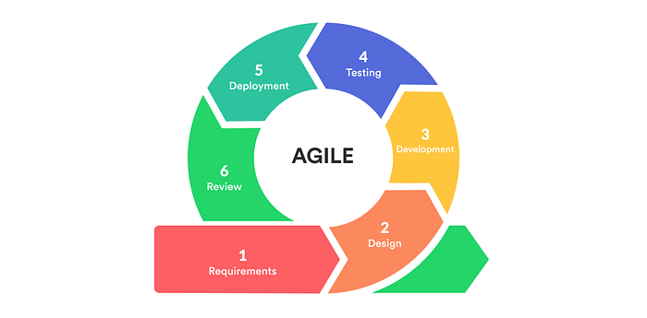
SYSTEM DESIGN
Agile Model

Figure 2. illustrates the Agile development model used in creating the web-based system for Nana’s Place Resort. The Agile model follows an process where the system is developed in phases and continuously improved testing and feedback.
Description each phase
- Requirements
In this phase, the needed features of the webbased reservation
system are identified.The researcher gathers information from the resort owner and users about booking, roomavailability, payments, andreports.This helps define wha the system should do.

Design

In this phase,the structure of the system is planned.The layout of the website,database, design, and systems flow for the reservation process are created.This ensures the system will be easy to use and organized.

Development
In this phase , the actual coding of the web-based reservation system is done.The developer creates the booking form,login page,admin panel,and database.All feature planned in the design phase are built here

Testing
In this phase,the system is checked for errors and problems.The developer test if reservation,login,and payment function work correctly.Fixes are made to ensure the system runs properly.

Deployment
In this phase, the finished system is installed and use in the resort.The web-based reservation system is uploaded online so customers can access it.The resort staff starts using the system for real reservation

Review
In this phase,the system is evaluated after use.Feedback from resort owner and users is collected. Improvements are planned for the next update of the system
Research Design
Locale of the Study
The study was conducted at Nana’s Place Resort, Barangay Sampinit, Bago City, Negros Occidental, Philippines. The research population comprised 30 individuals, consisting of 24 guests/customers, 5 resort staff members, and 1 administrator. Research activities were performed on-site to ensure direct engagement with the respondents and to gather pertinent operational data.
Sample Size
Table 1.0 Sample Size

Participant | Population
Guest/Customers | 24
Resort Staff | 5
Admin | 1
Total | 30

Sampling Technique
The researchers employed a convenience sampling technique to gather data from the administrator, resort staff, and guests
Respondents of the Study
The main participants of this study are the admin, resort staff, and guest/customers that involved in the Web-Based Reservation System Enhancing Efficiency and Guest Experience.
Research Instrument
The researchers used the ISO 9126 Software Quality Model through expert evaluation and the Computer System Usability Questionnaire (CSUQ) as the primary instruments for gathering data and evaluating the quality and usability of the developed Nana’s Resort Reservation System.
Reliability and Validity of Research Instrument
To ensure reliability, the instruments were tested through a pilot testing with a selected respondents to verify consisteny in results.For validity,the content of the instruments was review by the experts in system development and resorts operations to ensure that it accurately measures system effectiveness,usability,and user satisfaction.
Data Gathering Procedure
The researchers employed multiple methods to gather data for the development and evaluation of the Web-Based Reservation System for Nana’s Place Resort.
Observation.The researchers observed how the resort staff and guest interact with the current reservation process and the developed web-based system.This allows researchers to identify common challenges,usability issues,and areas where the system could improve efficiency and user experience.
Interview. The researchers interviewed the admin, staff, and guests to gather data on system requirements, address the issues, and learn about possible upgrades for the Web-Based Resort Management System.
Internet Reaserch.Relevant studies,articles,and online resources where reviewd to gather information about best practices in web-based reservation system,system design,user interface,and pament transaction.This help in designing a system that aligns with industry standard and modern trends in online booking platforms.
Data Analysis Procedure
The researcher analyzed the collected data using mean and grand mean and then provided corresponding verbal interpretations.
Context Flow Diagram
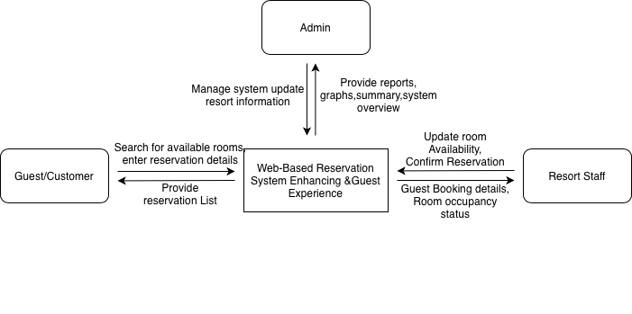

Figure 3. Context Flow Diagram
Figure 3 shows the interaction between the Guest/Customer, Resort Staff, and Admin with the Web-Based Reservation System. Customers search for available rooms and enter reservation details, while the system displays room information. Resort staff update room availability and confirm reservations, and the admin manages system settings, user accounts, and views reports. The system serves as the central platform for managing resort reservations.

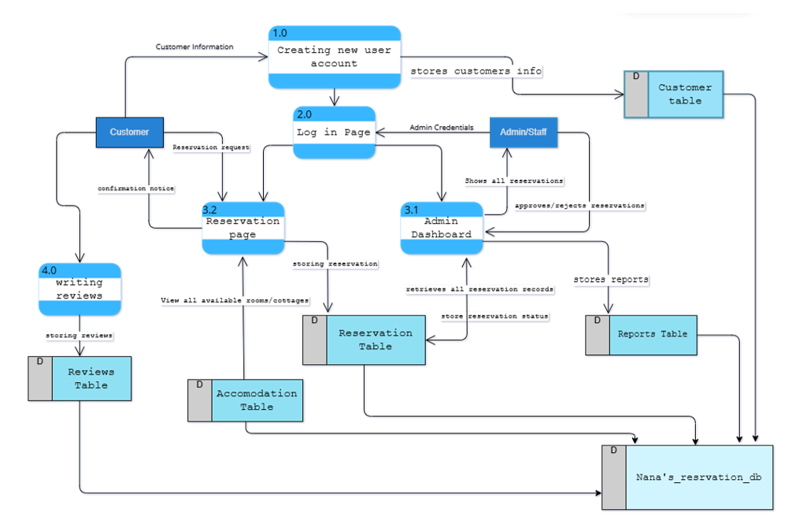
Data Flow Diagram

Figure 4. Data Flow Diagram
Figure 4 The data flow diagram illustrates how reservation data flows through the system. Customers provide reservation details which are processed and stored in the reservation database. The administrator accesses the stored information to manage reservations and generate reservation reports.

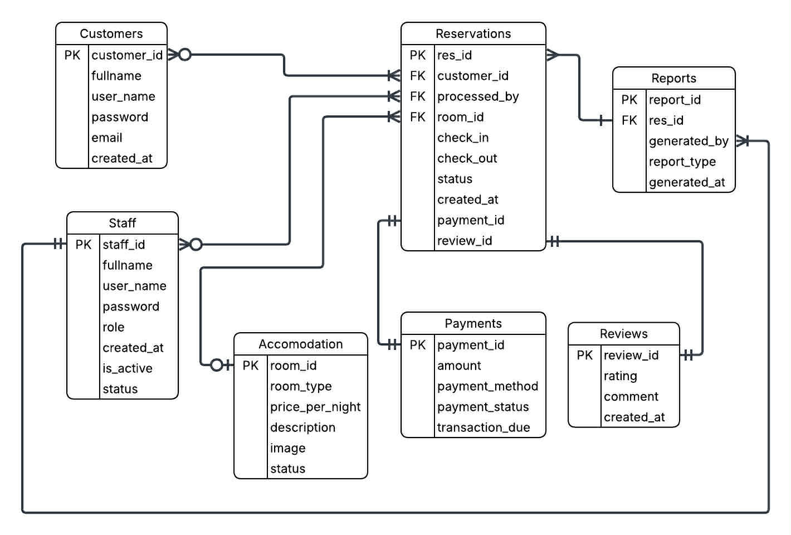
Entity-Relationship Diagram

Figure 5. Entity-Relationship Diagram (ERD)
Figure 5. The Entity-Relationship Diagram (ERD) illustrates the structure of the database for the web-based reservation system. It shows the key entities such as Customers, Staff, Reservations, Accommodations, Payments, Reviews, and Reports, along with their relationships. The ERD defines how data is connected and organized, ensuring efficient management of reservations, transactions, and customer information within the system
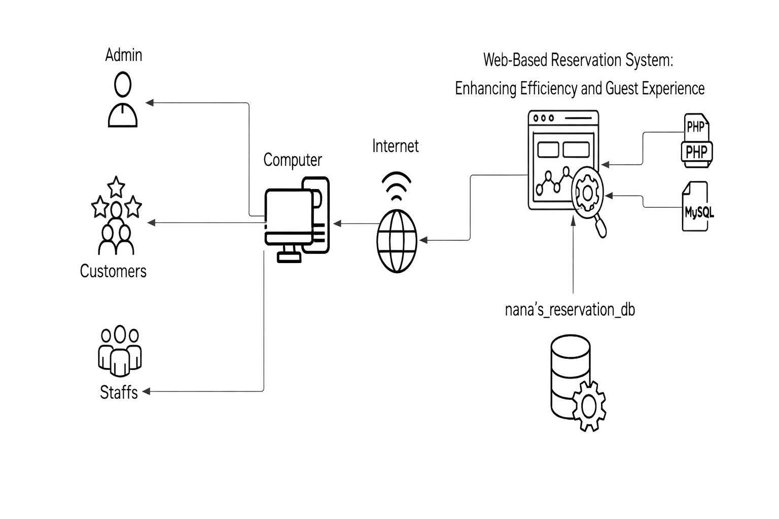
Application Architecture

Figure 6. System Architecture

Figure 6 shows the system architecture of the web-based reservation system. It illustrates how Admin, Customers, and Staff access the system via the internet. The system processes requests using PHP and stores data in a MySQL database (Resort_2_0), ensuring fast, organized, and reliable reservation management.

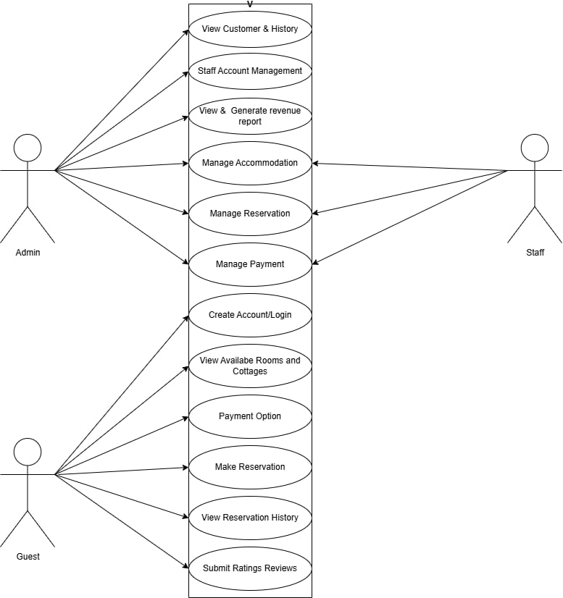
Use Case Diagram

Figure 7. Use Case Diagram
Figure 7 shows the use case diagram of the resort reservation system with three users: Admin, Resort Staff, and Customer/Guest. Each user has different functions such as managing accounts, handling reservations, processing payments, and viewing available rooms. The diagram shows how users interact with the system to complete reservation and management tasks.
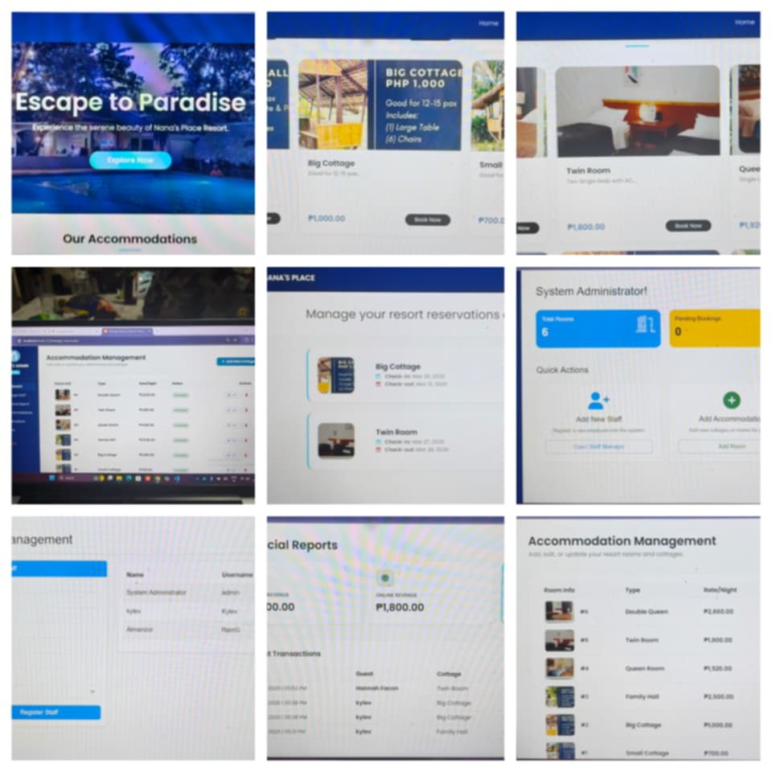
User Interface Design

Figure 8. User Interface Design

Figure 8. shows the user interface of the resort reservation system. It includes the login page, booking page, feedback section, and admin dashboard where users can manage reservations, payments, and room availability. The interface is designed to be simple and easy to use for admin, staff, and customers.
SERVER SIDE | CLIENT SIDE
Operating System  (Windows10,11) | Web Browser Support
Language HTML,PHP
Online Server
MYSQL Database
Software Requirements

Hardware and Other Required DeviceS
SERVER SIDE | CLIENT SIDE
Processor: 2 CPU cores or higher | Web Browser Support
RAM: 4GB or higher
Disk Space: 200 GB or hiher

CHAPTER IV

PRESENTATION, ANALYSIS, AND INTERPRETATION OF DATA
CHAPTER V
SUMMARY, CONCLUSION, AND RECOMMENDATIONS
Summary of Findings
Conclusion
Recommendation
REFERENCES
APPENDIX A
APPENDIX B
APPENDIX C

